Table of Contents

1 Overview

1.1 Chapter: Concept
A fast-paced local multiplayer side-scrolling racing game where you and your fellow grandmas go head-to-head in a thrilling race for survival! Once lifelong friends, you now find yourselves in a desperate dash to outrun death itself, because only one granny can make it out alive.
Use speed, strategy, and a little sabotage to outmaneuver your opponents and claim your escape. Friendship was great while it lasted, but in this race… it’s every granny for herself!
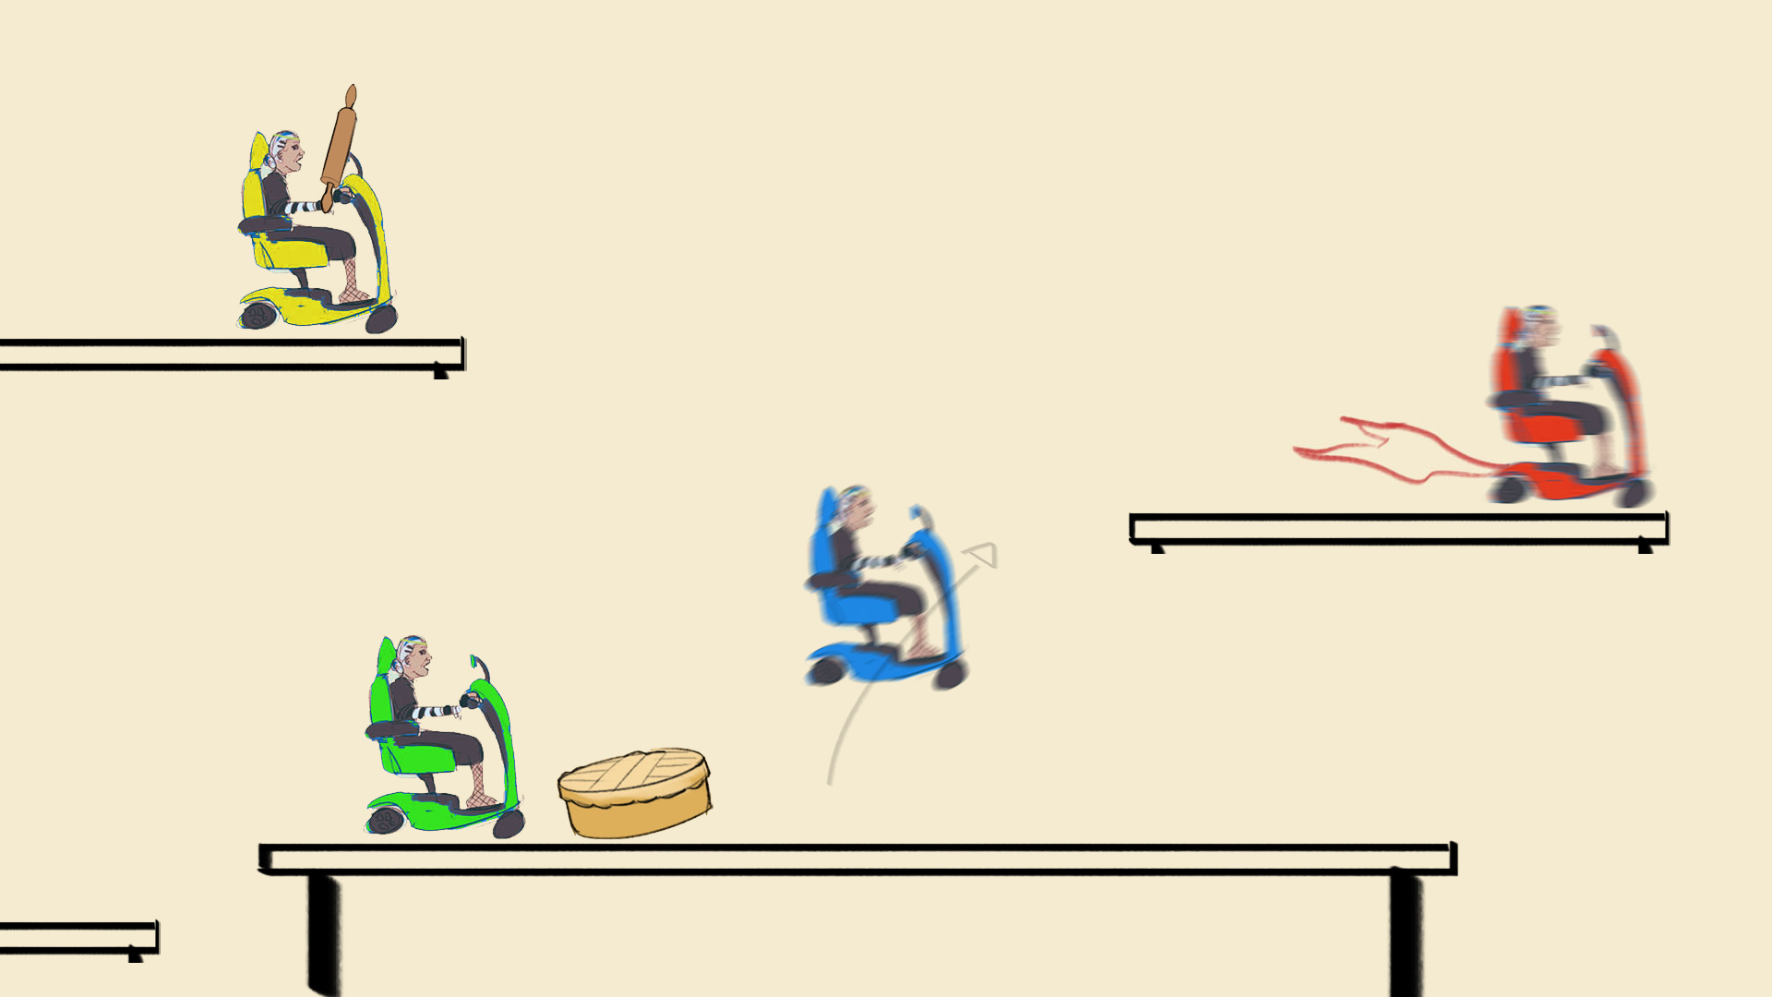

1.2 Chapter: Genre
This game is a fast-paced, local multiplayer, side-scrolling racing experience with elements of party chaos and competitive mayhem. Blending arcade-style racing with action-packed platforming, players must navigate treacherous courses, avoid obstacles, and use strategic sabotage to outlast their opponents. The game also features a battle royale twist, where only one player can survive, adding an intense and comedic layer of last-granny-standing gameplay. With its blend of speed, strategy, and unpredictable encounters, this game delivers a thrilling mix of racing, action, and party game fun.
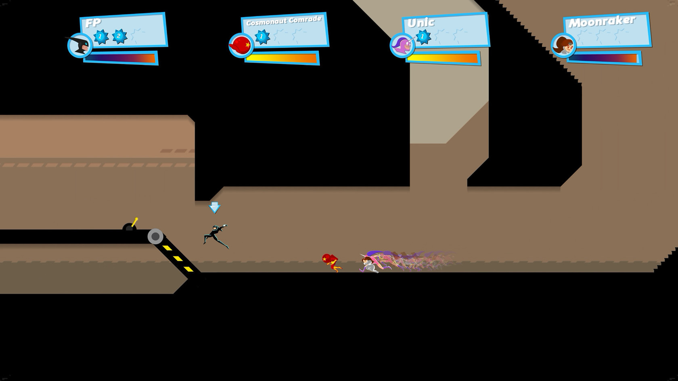

1.3 Chapter: Theme
Since you will be going through a retirement house with the elderly, the themes would be preserverance, nostalgia and death. The grandmas will relive their past with their friends as past events will be displayed in framed pictures in the environment. They will try to preserve against all odds of the inevitable called death which is chasing them until one remains.


1.4 Chapter: Story
Intro
In this world, 4 grandmas who are dear friends are reminiscing in a retirement house. However, at the time they share their dearest memories. A mysterious figure appears to take them to their final voyage but receive a bet as well. When one reaches the shining gate, they'll walk with a clean slate. At this perilous state the friends turn to one another to get to the finish line.
Finale
In the end when one reaches the gate they get to live on as they are but at the cost of losing their friends. As you see at the end credits (if we have time) the grandma looking back at the corpses with x crossing their eyes and having left this mortal realm.
Twist
However, this can turn sideways as well, if all grandmas get eliminated. All will greet death as a friend. And if 2 or more grandmas were to be reaching the door at the same time. None shall pass for it is only one who gets granted life.
Extra
There will be no side questing, only a straight path to cross over obstacles, as you traverse these platforms and mix chaos along the road.
(Since we won't have time we can't make these as cutscenes but are used as a general description)
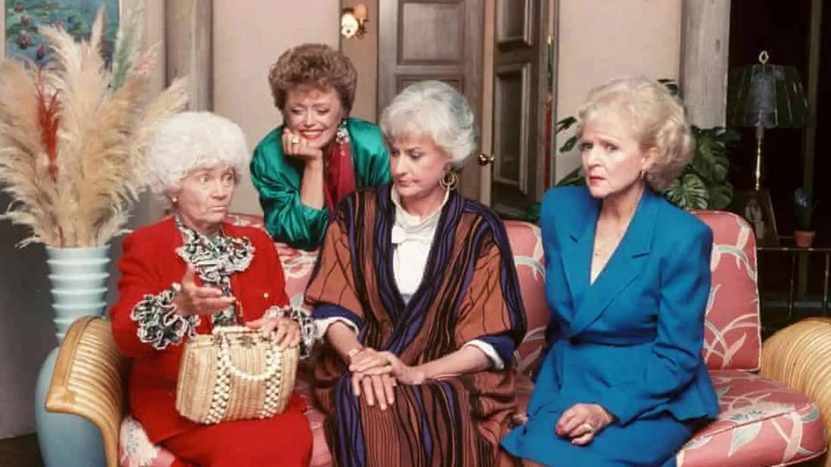
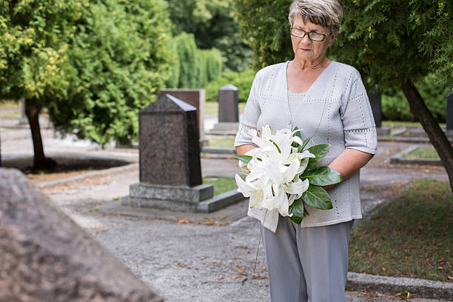

2 Gameplay

2.1 Chapter: Game Loop

2.1.1 Stage: Menus
We've got 4 menus worked out so far:
- Main menu
- Pause menu (if it were a complete game)
- Game over menu
- Level selection menu (if it were a complete game)
These will have scrabble letters spelling out the text of the buttons. When a cursor hovers over it, or when a player has a button selected, there will be an outliner shader activated that highlights the button.
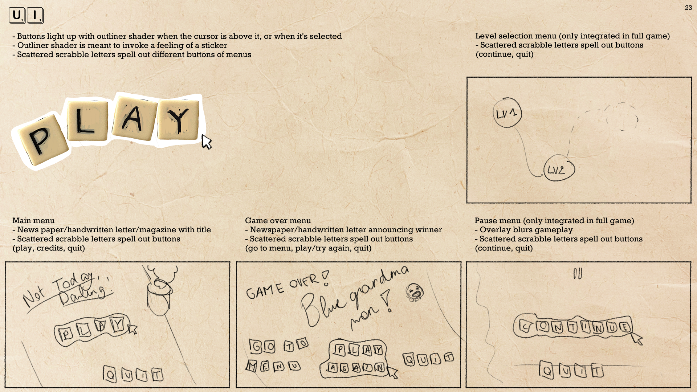

2.1.1.1 Chapter: Main menu
The main menu will have the buttons "Play", "Credits", and "Quit"
When the player activates "Play", the character selection starts.
When the player activates "Credits", a list of the developers and artists is displayed.
When the player activates "Quit", the game quits.
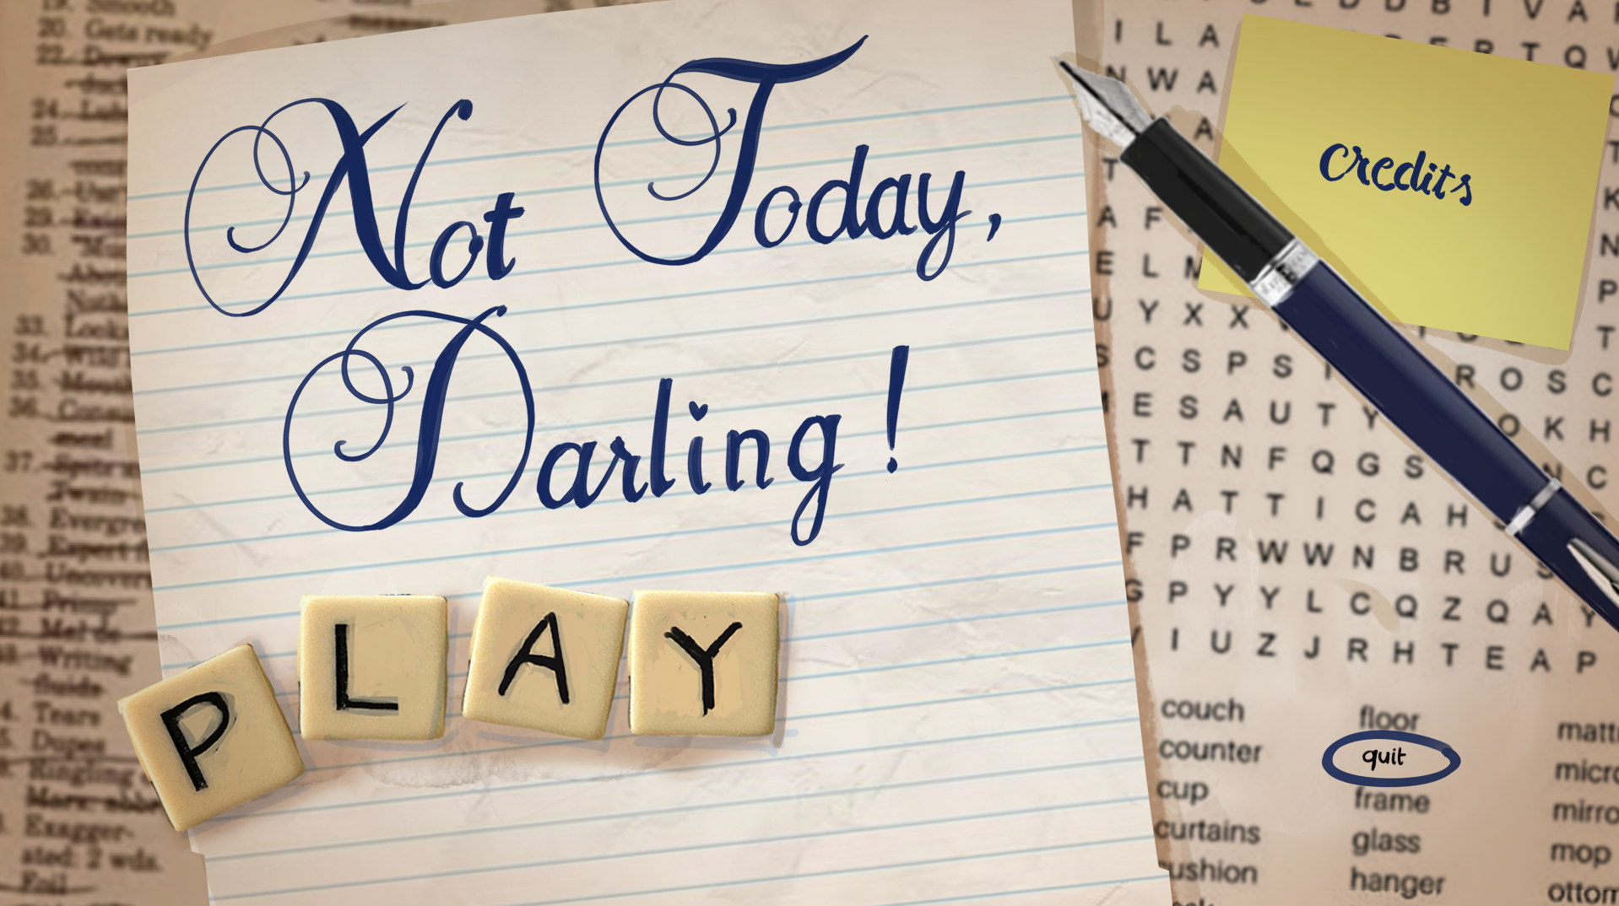

2.1.1.2 Chapter: Game over menu
The game over menu will have two states: "Death wins", or "Grandma wins"
"Death wins" displays when the last player is eliminated. There is a visual that displays that has to do with the visualisation of death.
"Grandma wins" displays when the first player crosses the end of the race. There is a visual that displays that celebrates the grandma that won.
The same buttons as the main menu, display, with the same functionality, but only is "Play" shown as "Try again?" for "Death wins", and "Play again?" for "Grandma wins". They're in a different spot, but work the same.
Additionally, there's a button "Go to menu", to go to the main menu.
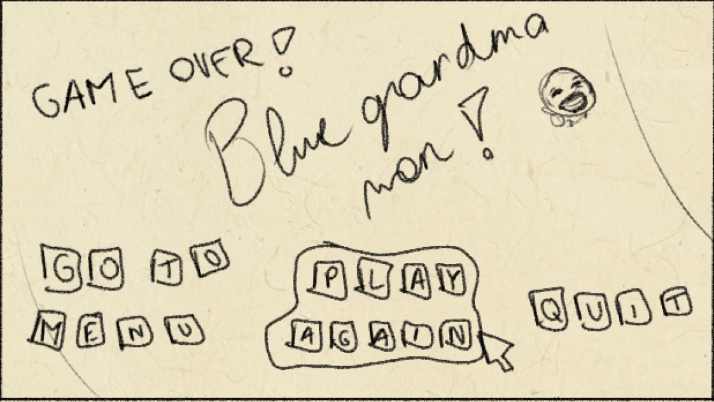

2.1.2 Stage: Character Select
Before the race begins, players will enter the character selection menu. To join the game, main players must press the "System" button on their gamepad.
Once connected, players can customize their character’s color by using the up and down buttons on the thumbpad.
Once all the players have pressed the ready button. It will start the game.
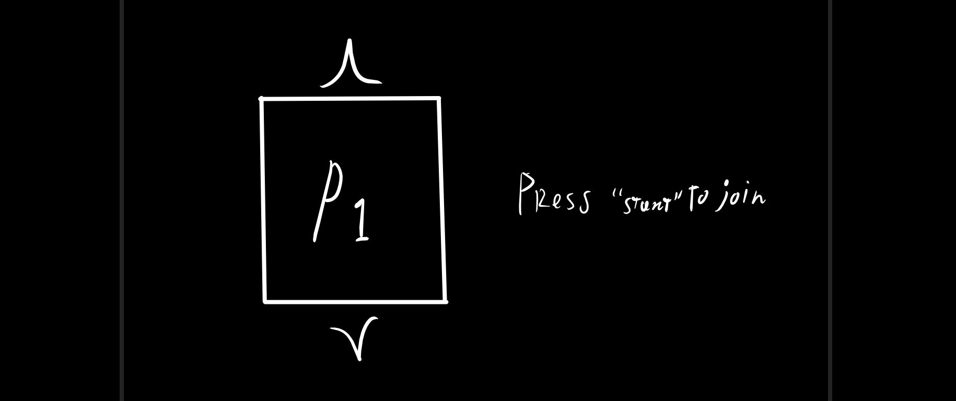
Only when 2 or more players are within the character select menu a menu will appear allowing for players to turn their state to 'ready'.
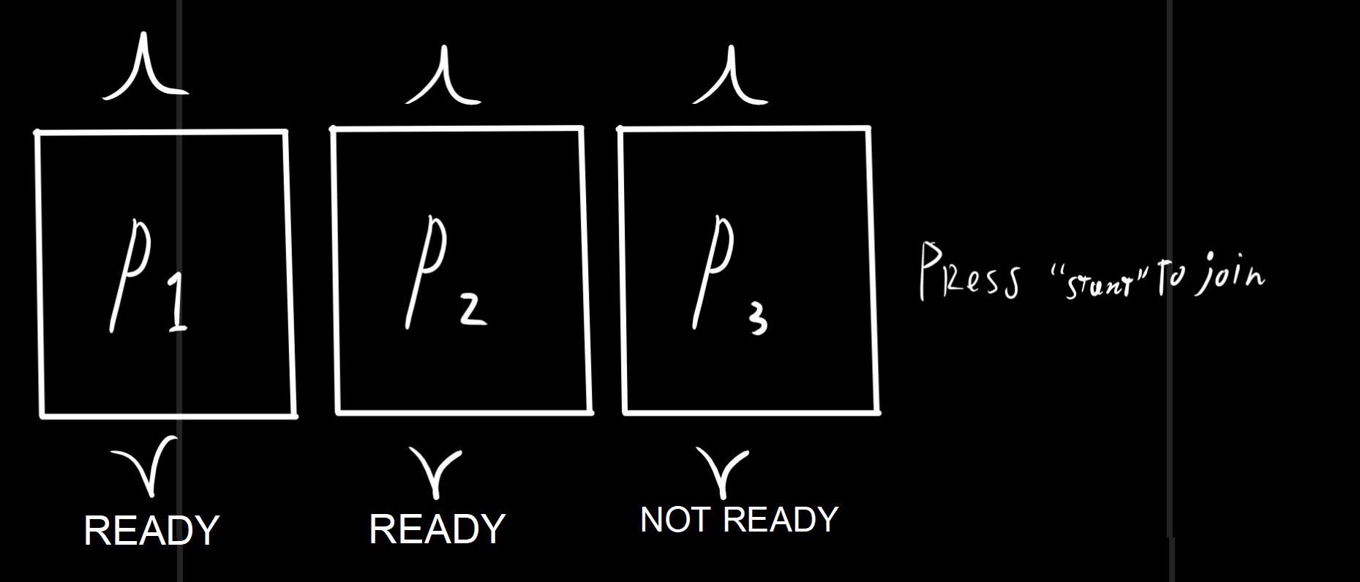

2.1.3 Stage: Race
At the start of the race, players will spawn sequentially in their designated starting positions, from First to Last place.
After a brief countdown, the race begins, and both the "Wall of Death" (also known as the elimination zone) and the camera will start moving steadily to the right. Players must keep up with the movement falling too far behind results in elimination.
Throughout the race, players can collect items that are randomly assigned with a slight bias based on their current position those in last place receive more powerful items, while those in the lead get less effective ones. The dynamic world also plays a key role, featuring speed boosts, slow zones, hover zones, and even hazardous falling zones where players can be eliminated if they misstep.
The race continues until either all players are eliminated or one player reaches the finish line. In the end, there can be only one winner or none at all.
Now the race doesn't end until either all the player are eliminated or one player finished. Because there go be only 1 winner or none.

2.1.4 Stage: End Of Race
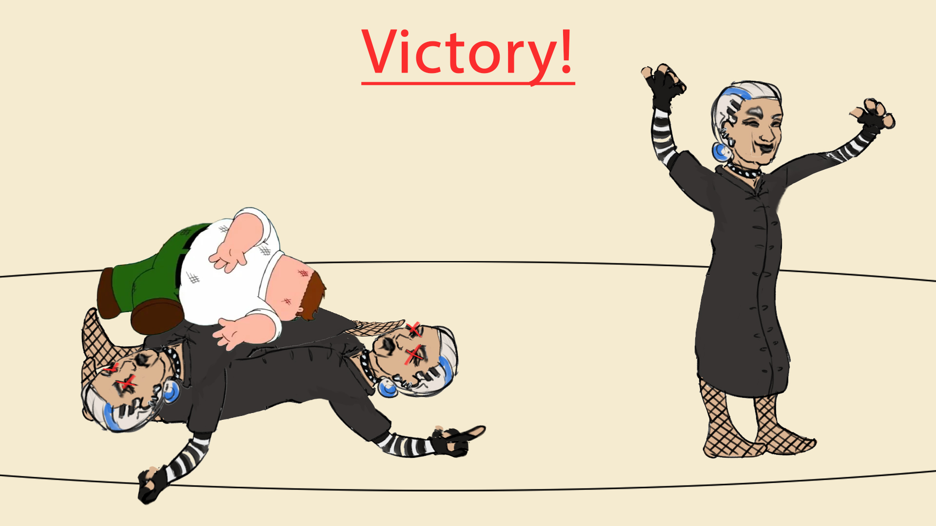
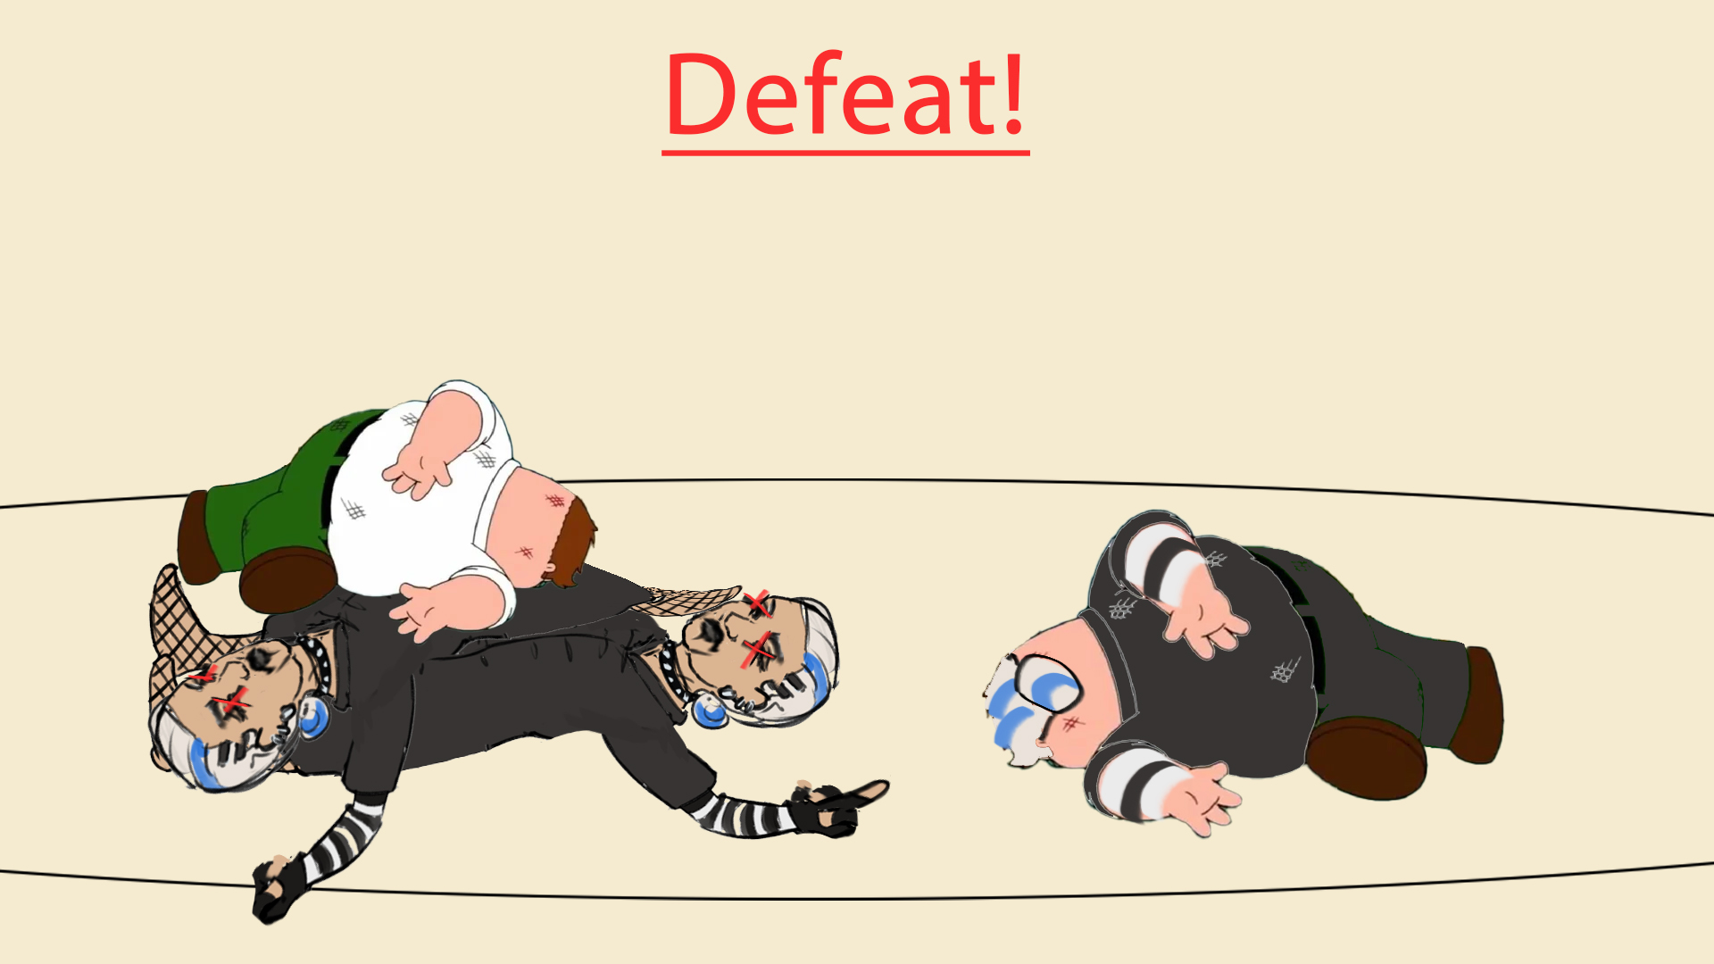

2.2 Chapter: Items
Items in this game are designed to either give players an advantage or throw their opponents off course, making it easier to catch up or maintain a lead. Strategically placed throughout the map, these items appear in consistent locations every race, allowing players to plan their routes and anticipate opportunities for clever plays and well-timed sabotage.
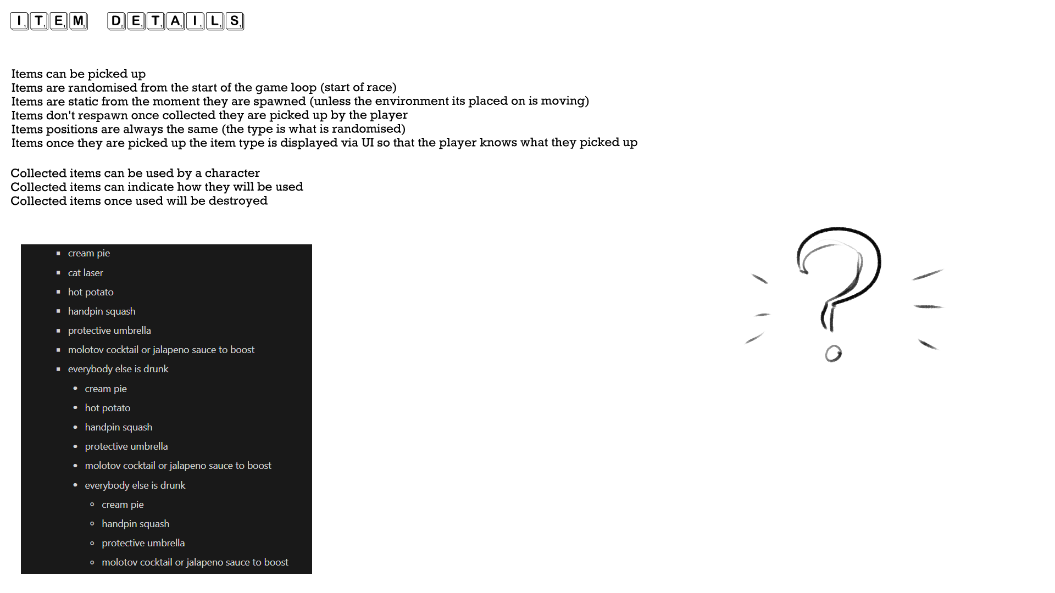

2.2.1 Object: Style
Items that have been picked up will need their proportions to be readable, meaning that they will pop up larger than a normal item would in ones hand. For instance a dough roller, it will appear almost as huge as the upper body of the grandmas. Proportion wise it will be wider and slightly longer and have their colours be distinct from the scene and characters holding it.
These items will therefore be in a similar as the grandmas themselves, but they will be made out of 3d crafted paper
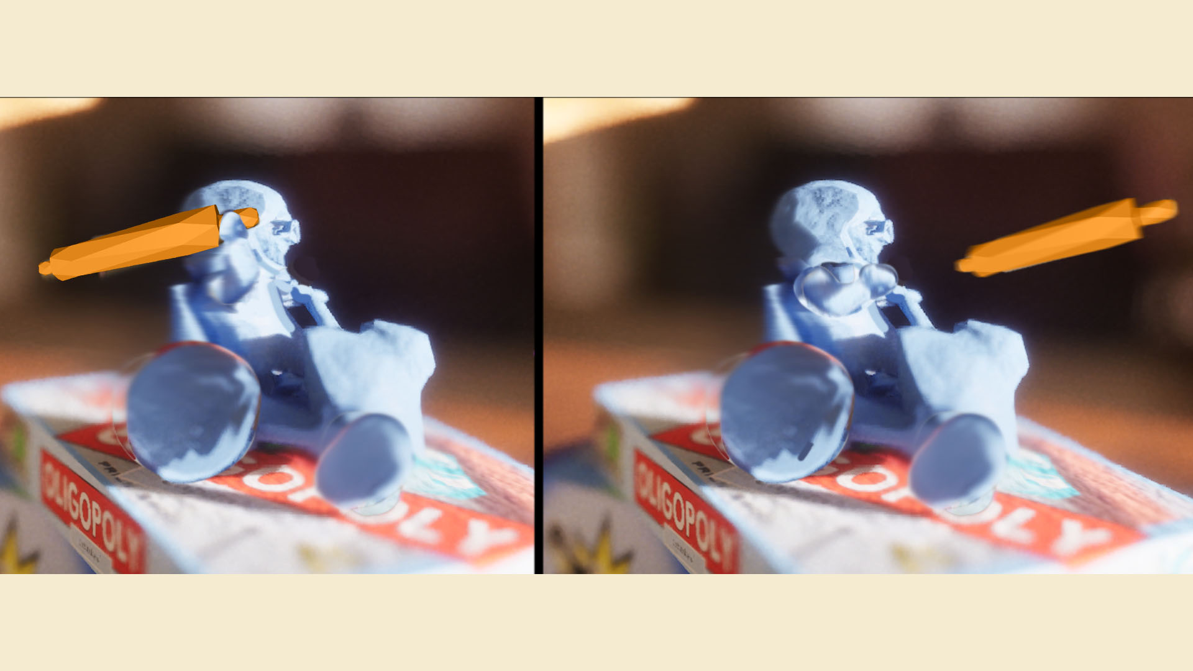

2.2.2 Chapter: Item Mechanics
The core aspect of the game is racing, outside that we have items that you rcharacter can easily pick-up. In the UI it will be visible that you can equip 2 of these tools. They can be used to either sabotage a player or defend yourself from a sabotage. The characters themself have little to no animated movements outside their arms rotating to show that they throw items for the offensive strategy.
Functionality
- Scattered items you can pick up
- 2 slots available that can't be replaced
- If an item has been used it opens a spot for a new one to fill in
- Press X to activate the item 1
- Press B to activate the item 2
Item types
- Defensive, ways to shield yourself from incoming attacks
- Offensive, ways to halt the enemy with projectiles or obstacles
- Boost, self improvement which let's you speed up
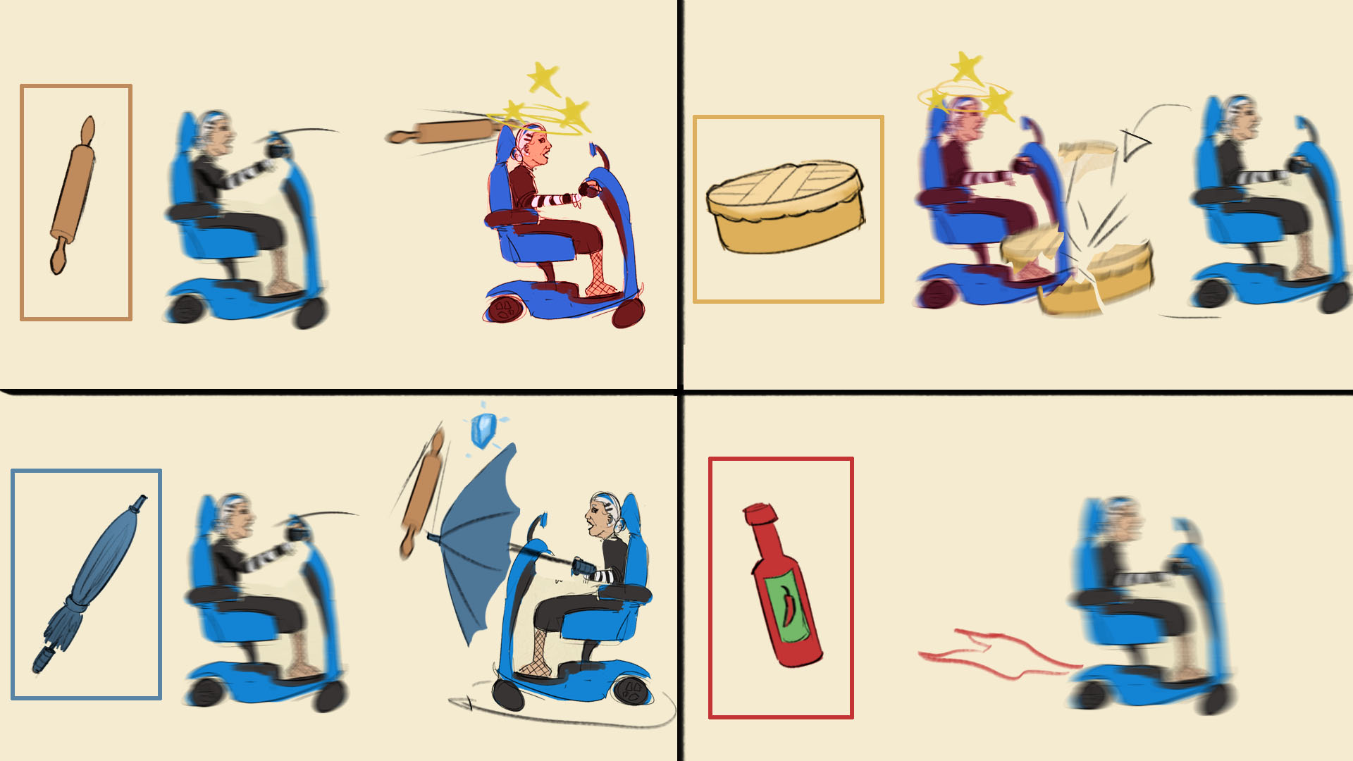

2.3 Chapter: User Interface
We want a very clean User Interface. Less is more. No clutter around the characters, only information around their own corner of the screen. The screen is reserved for actual gameplay and to enjoy the environment.
The HUD will show icons of the players in each 4 corners, with 2 icons of their pickups below.
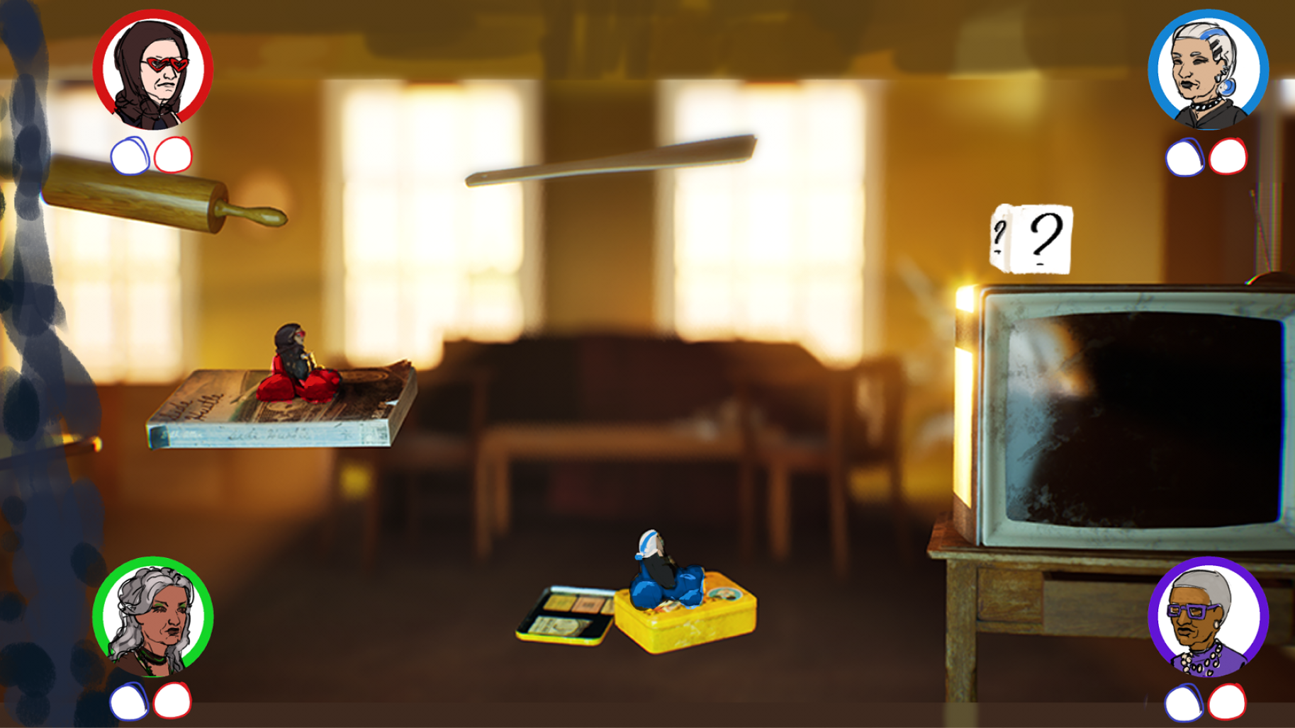

3 Characters
The grandmas are of course an inherent part of our game, so they need to have a lot of personality. The audience needs to fight over what grandma they want to play as. They're fun, quick-witted, and have a troublesome past, and that's extremely clear.
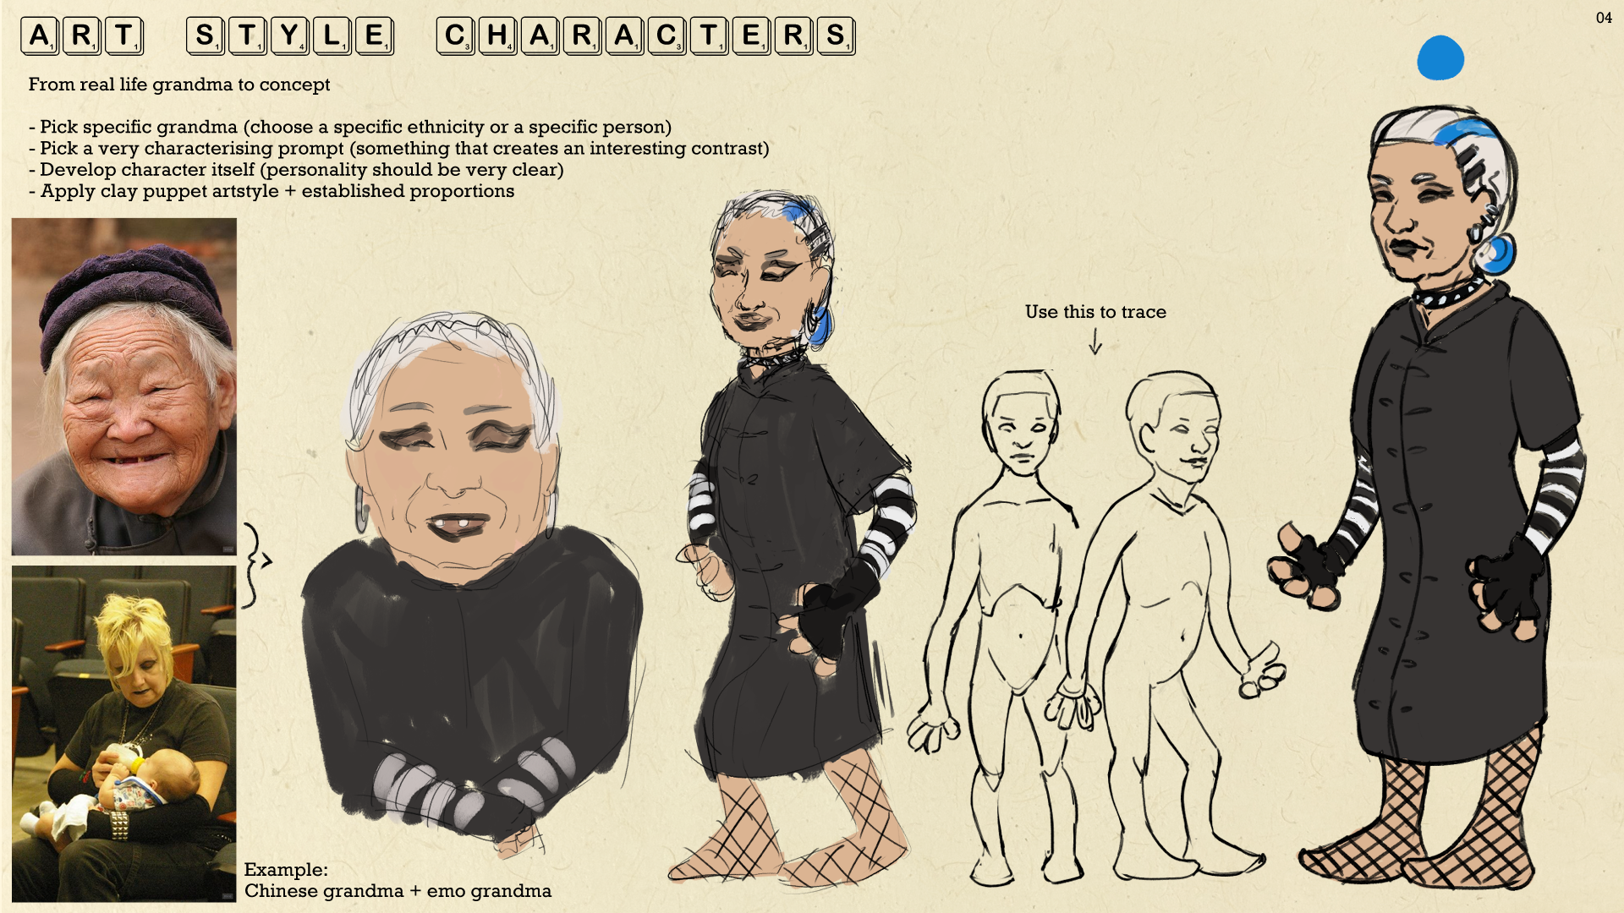

3.1 Character: Style
The characters are going to be clay-mation style. They will look and feel like a stop motion with a displacement map to make it look like the puppet is being molded into different stages of the animation itself. These characters are grandmas and will have a bit of a stylized approach like they do with the game "it takes two". As they are puppets, the grandmas are going to have vibrant colours so that they feel more cozy and homey. The textures will have PBR approach so that it will match the environment allong with the items.
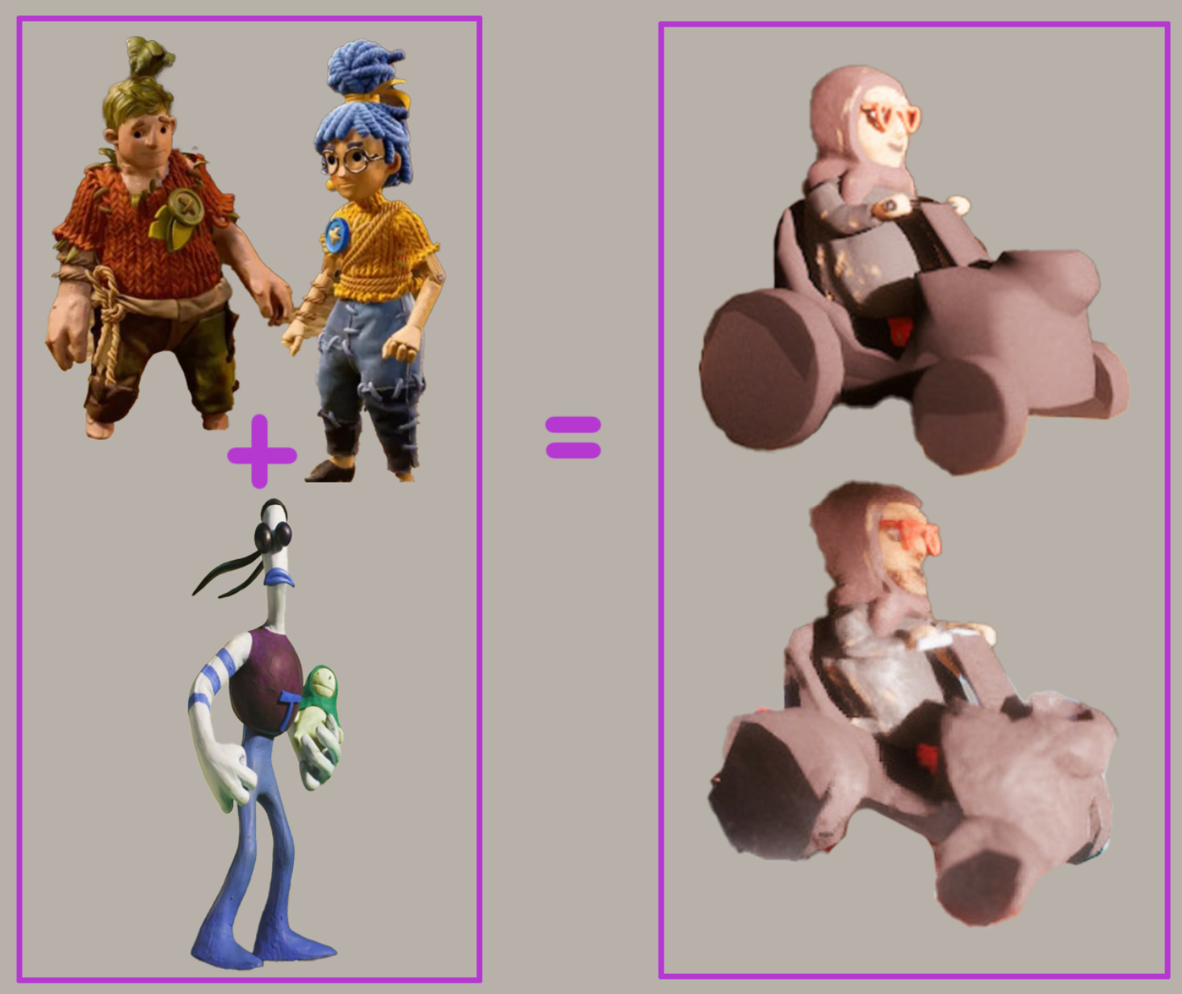

3.2 Chapter: Character Mechanics
The grandmas will be moving on a scooter to traverse the level. The left joystick will be used for movement while the A button will make sure you jump over obstacles or onto platforms. The B button will mainly be used to use consumables. These consumables are items you can gather across the level itself.
Mechanics
- Left joysticks will be used to move the character left or right.
- A button is used to jump.
- X button will be used to consume the left first item in your slots and B the second one
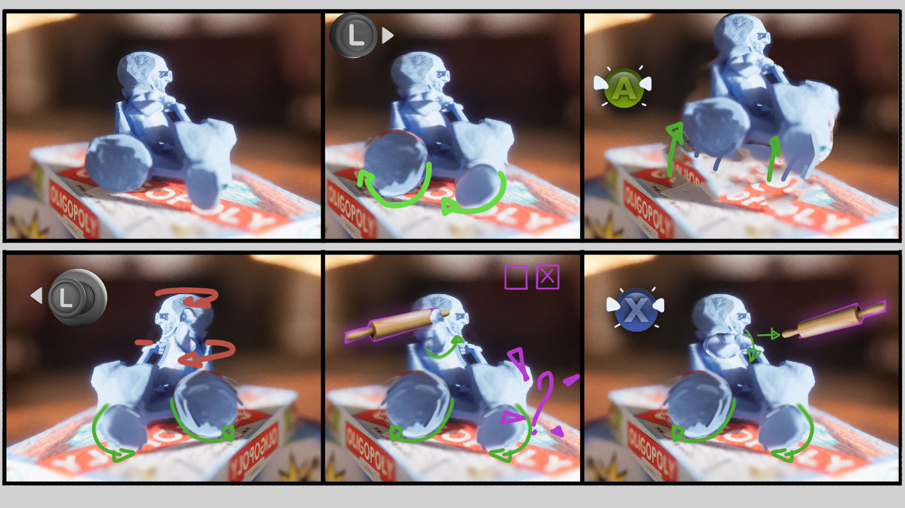

4 Levels

4.1 Chapter: Level Guide

Level Guide
Base Idea
When you create these platforms it needs to feel like you're going in a certain flow.
With it being fast paced you need to traverse a path but not one that leads to your demise but rather gives you a choice of paths to follow. The size of these platforms must at least be able to contain two grandmas on them length wise.
Engagement
Here you can implement a platform that is high up and isn't reachable going left to right but there might be a lower platform ahead to make it reachable from the opposite direction.
Why would you have such a platform? To put a pickable item so you encourage the player to traverse the path to have an item in store if you need or want one. And giving players this choice brings more engagement to the flow of the game.
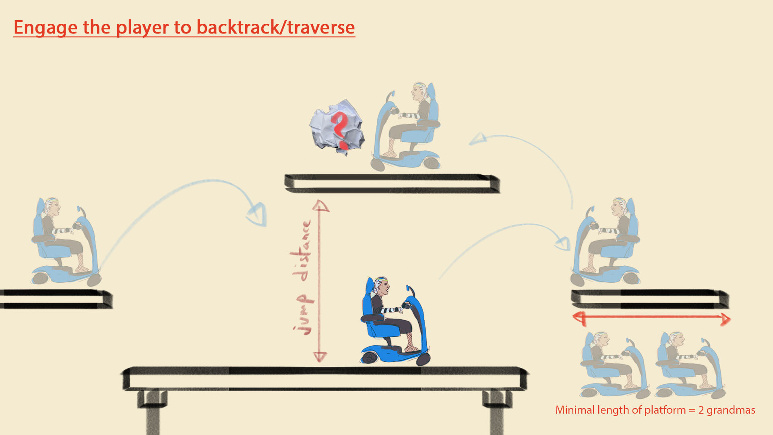
Be sure to add some variation that goes along and applies the same method of worflow, note that these scenarios don't have to contain pickable items, they can be used to dodge projectiles as hiding spots.
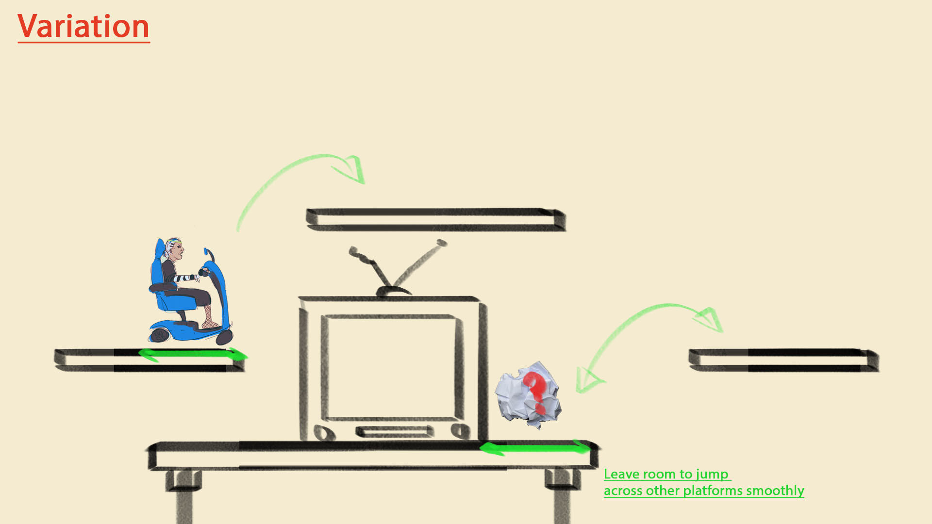
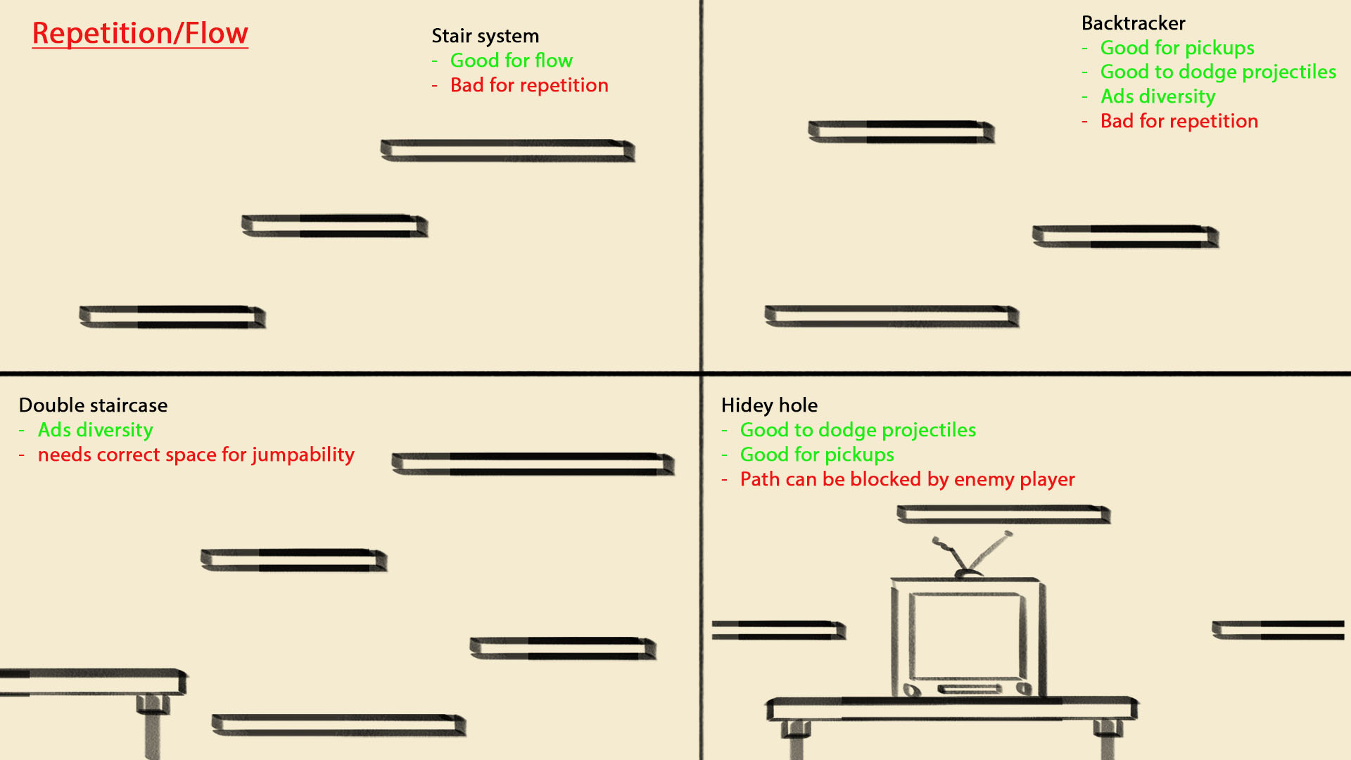
Down below you will see a rough vision how it will look in game.
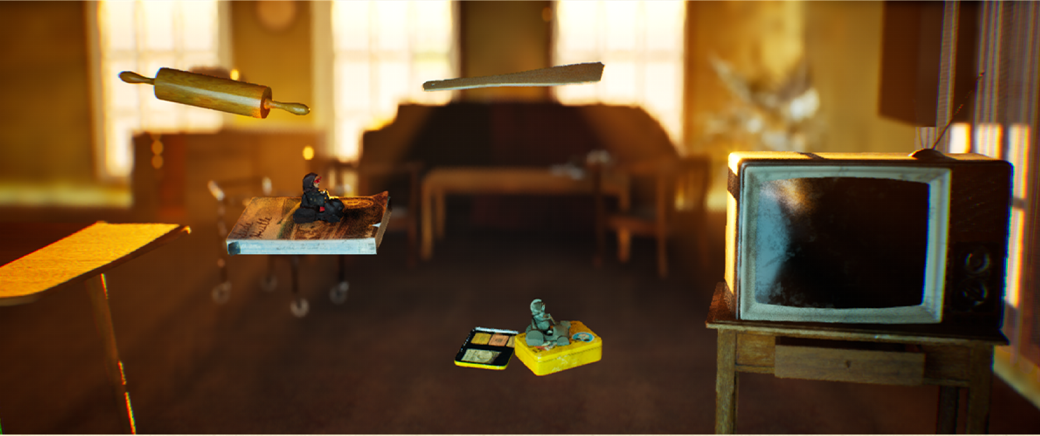

4.2 Chapter: Dynamics map features
Each level contains Dynamic Map Objects interactive elements that don't move but affect the player in unique ways. These objects create opportunities and challenges, adding depth to the race.
Spilled Jam
A sticky puddle of jam that slows the player down when they pass through it. Movement becomes sluggish, and any built-up speed is significantly reduced, making it a tricky obstacle to navigate.
Directional Fan (Speed boost) Element Stage: Race
A powerful fan that blows in the direction of the race, providing players with a temporary speed boost when they enter its wind stream. Perfect for gaining an edge on the competition!
Hovering Fan (Fly zone) Element Stage: Race
A fan that generates a strong upward gust, allowing players to hover or even fly while within its airflow. This opens up new movement possibilities, offering both freedom and strategic aerial navigation.
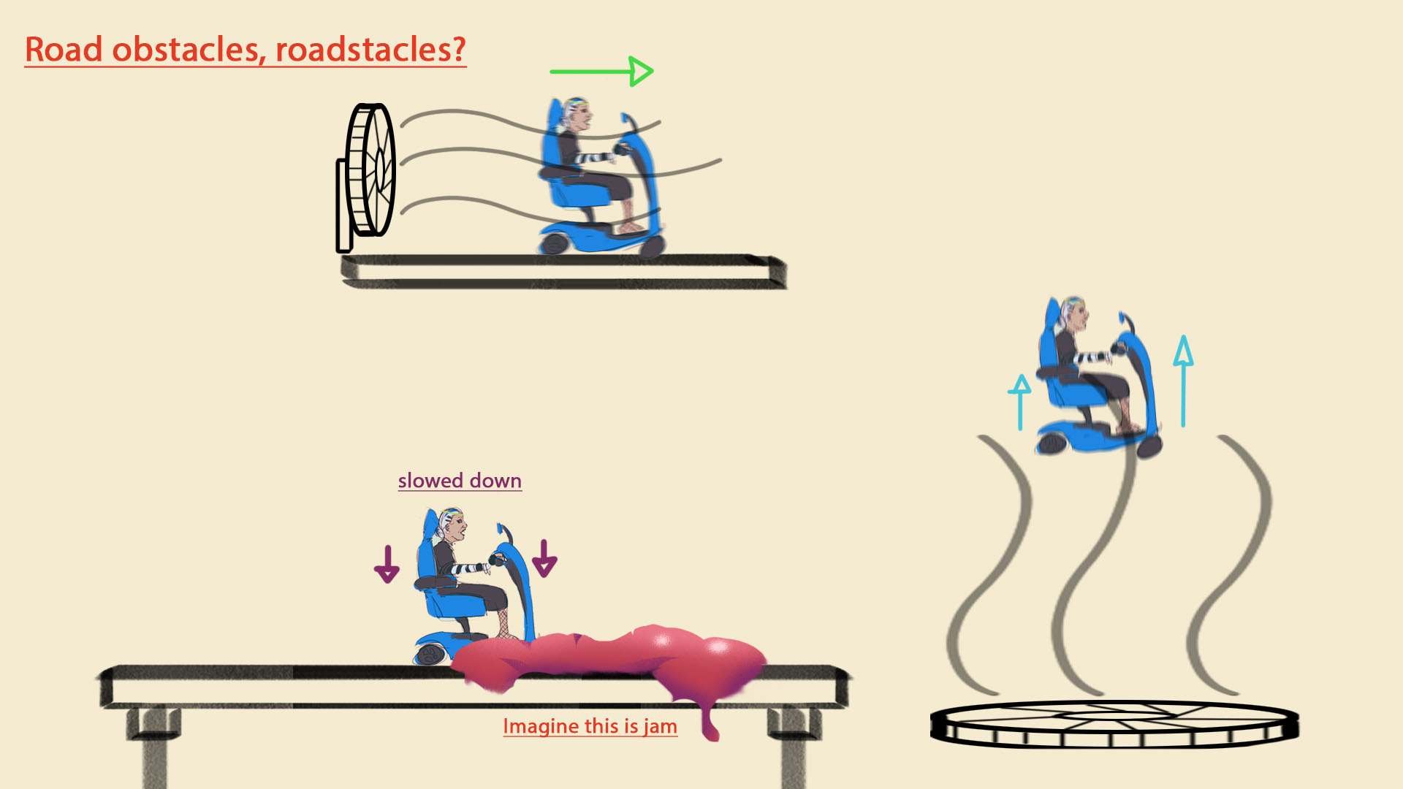

4.3 Chapter: Platform Assets
The grandmas will be platforming in an environment that is inherently tied to them. Not only is the background one that they spend a lot of time in, every single one of the items hovering around in there is theirs.
So, when we're trying to find more platform assets, we're looking for things that can have sentimental value for the grandmas, household items, things that have to do with their niche interests, or just general "old person" items.
